1. Consider the following code what will the console.log output be and why? Name the JS rule that is responsible for this behavior.

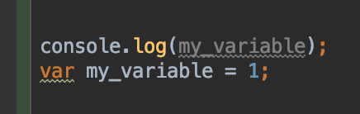

1. Create a function named parseUrl(string) which will receive URL string as parameter and will return an object with parsed data as shown in the following demo. Make sure you support IE10.

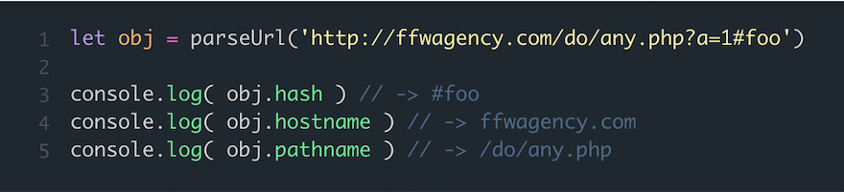

1. Consider the following data object. Use ES6 feature to easily create variables that extract and store values from the data object to obtain:

* A variable called “names” that will contain data.names
* A variable called “enrolled” that will contain value from data.enrolled but will default to “false” in case data.enrolled doesn’t exist or is not usable
* A variable called “marks” that will contain value from data.marksss

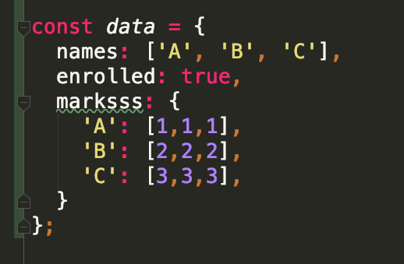

1. Consider the scenario from the image below. You have a “functionality” helper object that you reuse. In it you attach a click handler called “clickListener” that should ultimately change “isActive” and call “checkTriggered”. When a user clicks on a link: will your code execute correctly? If not – how should we fix it while keeping this original object structure?

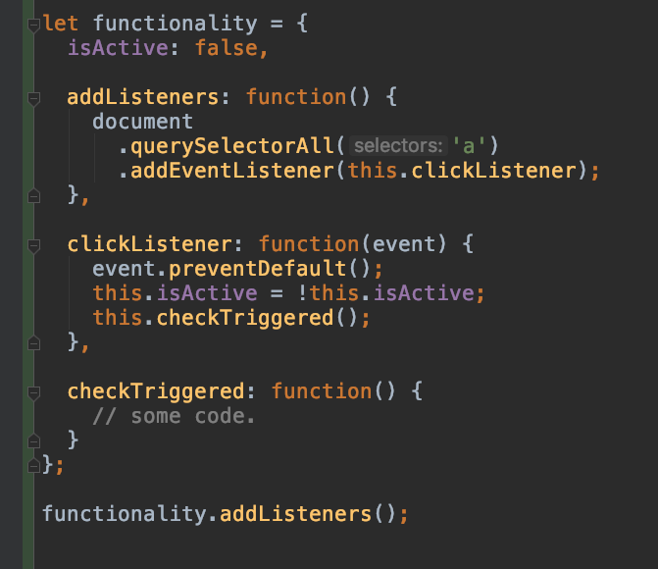

1. You work on a jQuery project. Considering the following HTML code on a page. You need to extract all div.node only from the articles wrapper. How many ways of selector-picking using jQuery can you enumerate for this case?

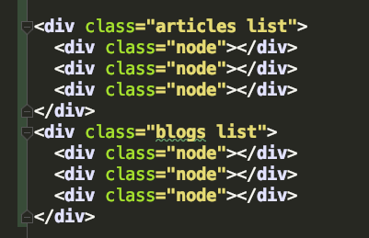

1. Write a short JS snippet that pulls JSON users data from <https://jsonplaceholder.typicode.com/users>. Once you have the data print a div for each user instance object received like in the following example:

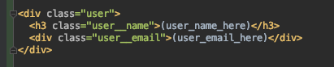

1. At what point do you recommend to run AJAX requests (or trigger other asynchronous tasks) during a React Component lifecycle? Why?
2. Considering the following react component please pick one or more correct ways of passing a handler to a component. Also, explain what happens when you click each button from this component?

